**DAILY ONLINE ACTIVITIES SUMMARY**

|  |  |  |  |  |  |  |  |  |
| --- | --- | --- | --- | --- | --- | --- | --- | --- |
| **Date:** | **02/06/2020** | | | | | **Name:** | **AKASH S** | |
| **Sem & Sec** | **4TH&A** | | | | | **USN:** | **4AL18CS004** | |
| **Online Test Summary** | | | | | | | | |
| **Subject** | |  | | | | | | |
| **Max. Marks** | | **30** | | **Score** | | |  | |
| **Certification Course Summary** | | | | | | | | |
| **Course** | **INTRODUCTION TO DATA STUDIO** | | | | | | | |
| **Certificate Provider** | | | **GOOGLE** | | **Duration** | | | **4.5 HOURS** |
| **Coding Challenges** | | | | | | | | |
| **Problem Statement 1:** **Given an array arr[] of integers and an integer K, the task is to print all subsets of the given array with the sum equal to the given target K.**  **Problem Statement 2:** **Write a program in java, an array of integer data to be initialized. During the initialization, if a user enters a value other than integer value, then it will throw InputMismatchException exception. On the occurrence of such an exception, your program should print “You entered bad data.” If there is no such exception it will print the total sum of the array.** | | | | | | | | |
| **Status: executed** | | | | | | | | |
| **Uploaded the report in Github** | | | | | **YES** | | | |
| **If yes Repository name** | | | | | <https://github.com/akashacharya786/lockdown-c-coding>  **https://github.com/akashacharya786/lockdown-java-coding** | | | |
| **Uploaded the report in slack** | | | | | **YES** | | | |

Online Test Summary:

no test are conducted

**Online Certification course:**

Today I have started a new course

Name of the course : introduction to data studio

Duration:4.5 hours

Certificate provider: google

This course contains 4 modules. Today I have completed 2 modules.

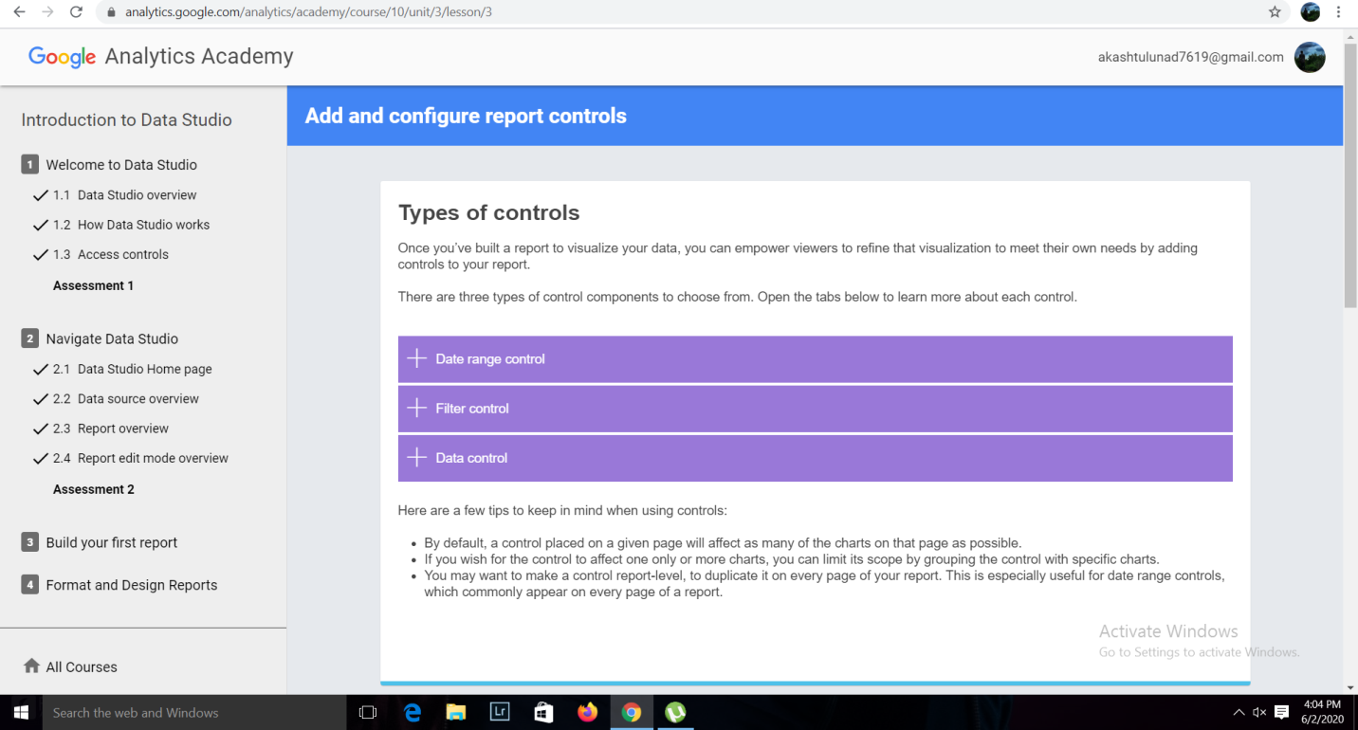

Online Coding summary:

1. **Given an array arr[] of integers and an integer K, the task is to print all subsets of the given array with the sum equal to the given target K.**

2. **Write a program in java, an array of integer data to be initialized. During the initialization, if a user enters a value other than integer value, then it will throw Input MismatchExceptionexception. On the occurrence of such an exception, your program should print “You entered bad data.” If there is no such exception it will print the total sum of the array.**

